AI Retail Intelligence Platform

Build an AI-powered Retail Analytics Platform that helps retail businesses analyze sales, identify business trends, generate insights, and make data-driven decisions. This project is being developed step by step like a real software product.

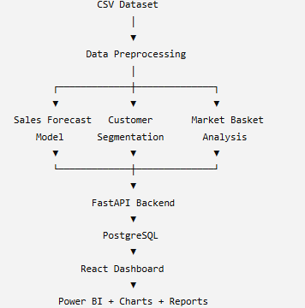
Final Architecture

Tech Stack
Backend | - Python  - FastAPI
AI | - Pandas  - NumPy  - Scikit-learn  - XGBoost  - Prophet  - MLxtend
Database | - PostgreSQL
Frontend | - React  - Tailwind CSS
Visualization | - Plotly  - Power BI
Deployment | - Render  - Vercel

📅 Day 1 – Project Setup & Foundation

Theme: Project Initialization

✅ Kya Kiya?
- Project folder structure create ki.
- GitHub repository banayi.
- VS Code environment setup kiya.
- Python Virtual Environment (venv) create kiya.
- Dataset folder banaya.
- Git initialize kiya.
- First commit aur GitHub push kiya.

📅 Day 2 – Exploratory Data Analysis (EDA)

Theme: Understanding the Dataset

✅ Kya Kiya?
- Dataset load kiya using Pandas.
- First 5 rows dekhi (head()).
- Dataset shape check ki.
- Column names identify kiye.
- Data types analyze kiye.

📅 Day 3 – Data Cleaning

Theme: Preparing Data for AI & Analytics

✅ Kya Kiya?
- Missing values check ki.
- Duplicate rows identify aur remove ki.
- Statistical summary nikali.
- Clean dataset generate kiya.
- Clean dataset save kiya.

📅 Day 4 – Data Visualization

Theme: Visualizing Business Data

✅ Kya Kiya?
- Sales by Category chart.
- Profit by Category chart.
- Sales by Region chart.
- Top 10 States chart.
- Profit Distribution chart.

📅 Day 5 – Business Insights

Theme: Converting Data into Business Decisions

✅ Kya Kiya?
- Top Products identify kiye.
- Top Customers identify kiye.
- Highest Profit States analyze kiye.
- Loss Making States identify kiye.
- Discount analysis ki.
- Correlation analysis ki.
- Business recommendations likhe.

📅 Day 6 – Automated Business Reporting

Theme: Automating Business Reports

✅ Kya Kiya?
- Total Sales calculate ki.
- Total Profit calculate ki.
- Total Orders calculate kiye.
- Average Sales nikali.
- Top Category identify ki.
- Top Customer identify kiya.
- Automated Business Report generate ki.
- Report .txt file me save ki.?

🚀 Day 8 – AI Retail Intelligence Platform

🎯 Theme: Your First AI Model (Sales Prediction)

🧠 Problem Statement
- Retail store owner poochta hai:
- "Agar mujhe Product Category, Quantity aur Discount pata ho, to expected Sales kitni ho sakti hai?"

🚀 Day 9 – Feature Engineering (Real Data Scientist Work)
Machine Learning me algorithm se bhi zyada important hota hai Feature Engineering.

📌 Current Tech Stack
• Language: Python
• Libraries: Pandas, Matplotlib
• Tools: VS Code, Git, GitHub
• Data Format: CSV
• Version Control: Git

